P.G. DEPARTMENT OF COMMERCE
REPORT ON OPEN HOUSE
On November 26, the second B.com students 2020 – 2023 had an Open House. The meeting was held in order to discuss the academic performance of students in the Second Semester internal examination with their parents.
The formal function began with a welcome address by the class advisor, Dr. Athena Joy followed by addresses from Principal Dr. Rajumon T Mavunkal and Vice-Principal Dr. Gimson D. Parambil. The meeting appealed the cooperation of both parents and teachers to work for the betterment of academic and non-academic performance of the students.
A face-to-face interaction with the parent and teacher provides an opportunity to discuss the academic performance of the student. The meeting was effective and great platform for the holistic development of child’s future as both parents and teacher share their insights and helps to know the two sides of the student (strength, weaknesses, opportunities and threats). The open house concluded that the collaborative efforts of both parents and teachers are very important for the betterment of students. 27 parents have positively reacted towards the programme.

P.G. DEPARTMENT OF COMMERCE
REPORT ON ORIENTATION ON RESEARCH METHODOLOGY
To introduce students the conceptual approaches of research as well as to explore and formulate the theoretical framework for the analysis of research problem, Department have organized an orientation programme on ‘Research Methodology’ for final year degree students on 20th and 21st January 2022. The resource person was Dr. Mathew Abraham, who have addressed all the queries raised by the students. The session enabled the students to define research problem and helped to develop an approach to research problem. 34 students have attended the program.

P.G. DEPARTMENT OF COMMERCE
REPORT ON COMMERCE ASSOCIATION INAUGURATION
Commerce Association ‘EFTERAR’ for the academic year 2020-21 has been inaugurated on 7th March 2022, Monday. The Chief guest for the day was Mr. Hari K.R., (SBI Regional Manager Kottayam). The inaugural ceremony was commenced by invoking the blessings of Lord Almighty. Ms. Aleena Varghese, President of Commerce Association welcomed the gathering, Dr. Gimson D Parambil, Vice Principal delivered the presidential address. College Principal Dr. Rajumon T Mavunkal and IQAC Co-ordinator Dr. Tomy Joseph felicitated the function. The Association has honoured Ms. Amrutha D (IV Rank holder, M.G University examination), Ms. Linda Baby (M.Com College Topper, M G University examination 2019-20), Ms. Aswathy P (M.Com College Topper, M G University examination 2020-21) and Ms. Praveena Babu (B.Com Topper, M G University examination 2019-20). Association has also rewarded Mr. Adrash D for his excellence in swimming and Mr. Prathesh Babu for securing Ist runners-up trophy for Gymnastics in Kottayam District.
On the same day, a talk on the topic ‘Blockchain Technology: Cryptocurrency’ was also organised and Chief guest was the speaker. He has shared his knowledge and experience in the area and also explain the opportunities and challenges in the emerging blockchain technology. Thereafter, cultural programmes of the students as class-wise has conducted.
The Association has also provided lunch to all students and teachers of the department on the said day. For the effective functioning of the association, a fund was raised from students’ i.e ₹150 per student and a total of ₹19,650 (150x127) was collected. Total expense for the day amounts to ₹19,910 and the deficiency of ₹260 was settled from the department.

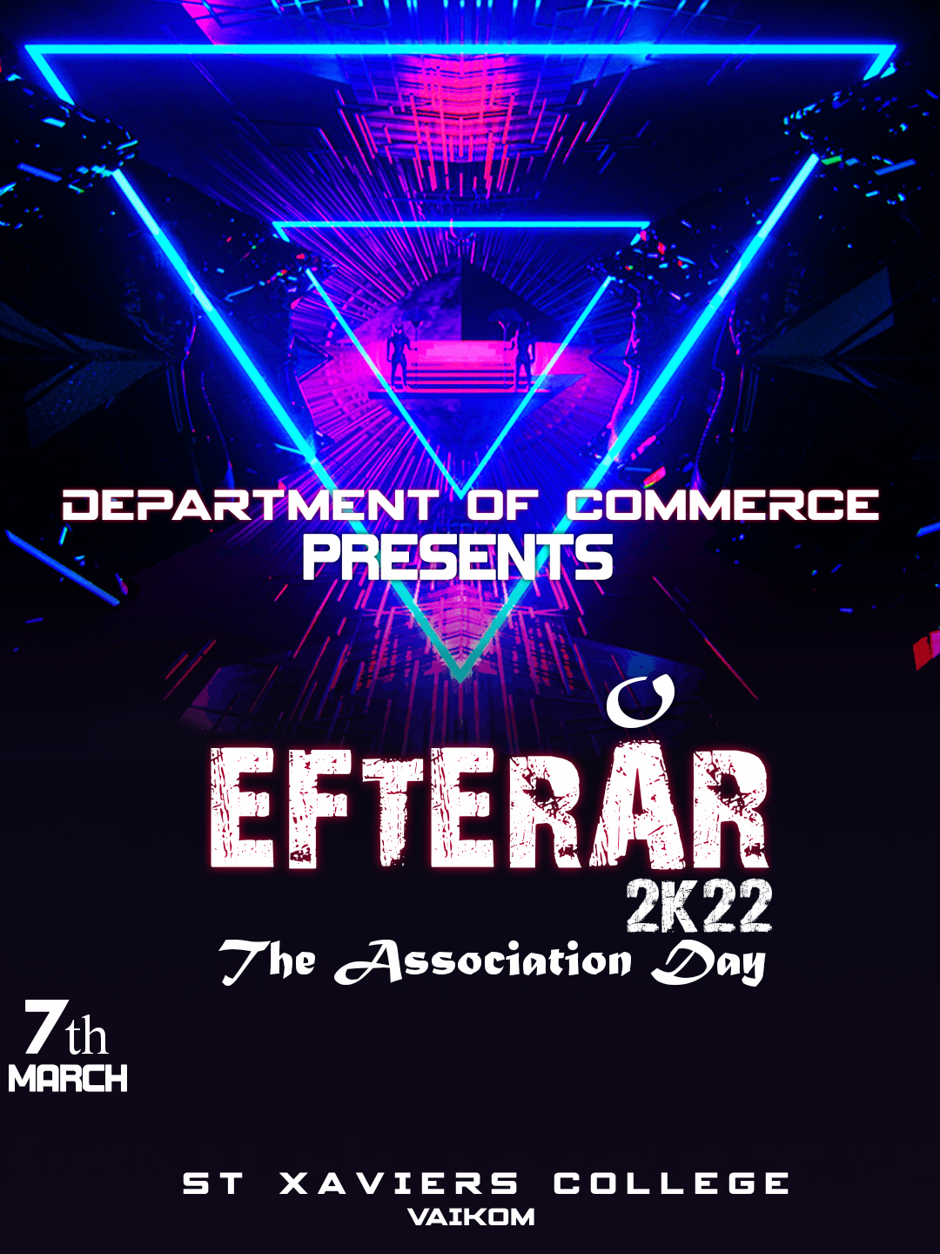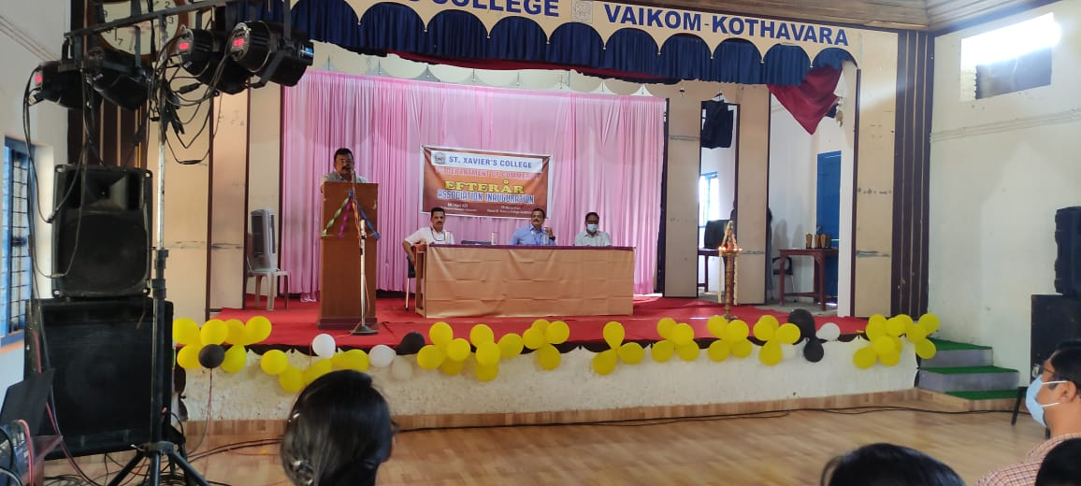
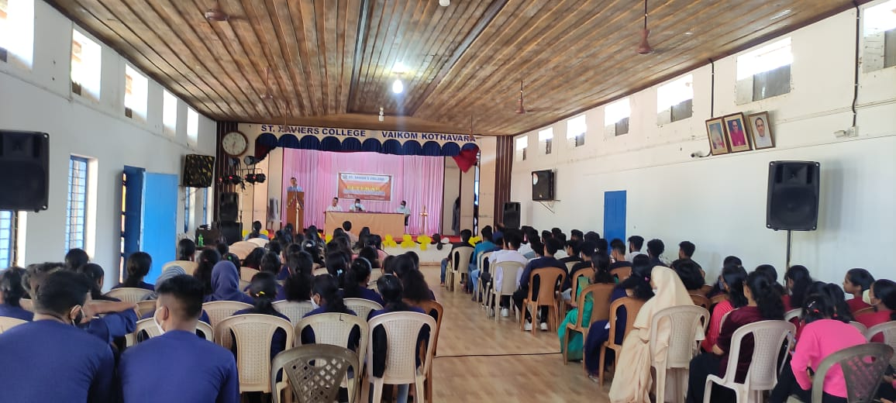
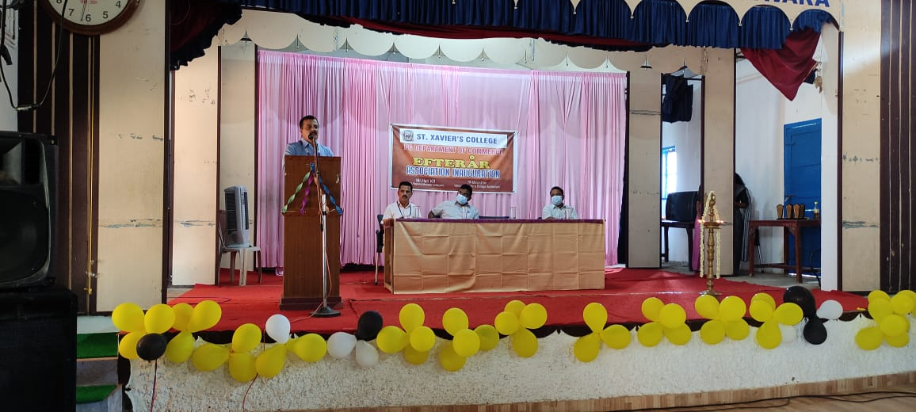
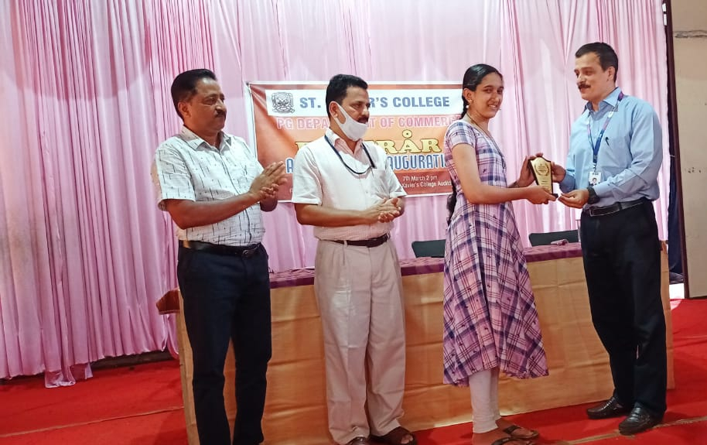
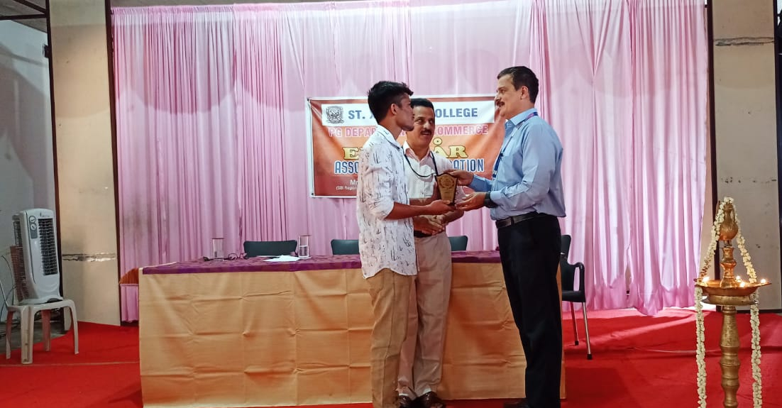
P.G. DEPARTMENT OF COMMERCE
REPORT ON EXCURSION
P G Department of Commerce has organized 2 days and 3 nights excursion for final year B.Com students to Wayanad from 19th to 22nd May 2022. Trip was arranged on package basis with Campus Tour Planners, each student has contributed ₹4,500 towards the trip and 23 students joined with the event. Students had an experience to view certain tourist spots at Wayanad and also the methodology of maintaining such places hygiene and attractive. Mr. Aravind D, Mr. Aswin Sukumaran, Ms. Anandasree Kammat and Ms. Sriya Vijayan was selected as organizing committee, who were also assigned to handle financial matters too. Day 1 they visited Edakkal caves, Kanthanpara waterfalls and sight-seeing and in at night they had DJ party. On the 2nd day, they visited Kuruvadweep and Banasura Dam and also had a facility for shopping. After dinner most of them have shared their experience and next day early morning by 5:30 a.m they reached back at college. Dr. Titto Varghese and Ms. Anju T.A has accompanied the students.
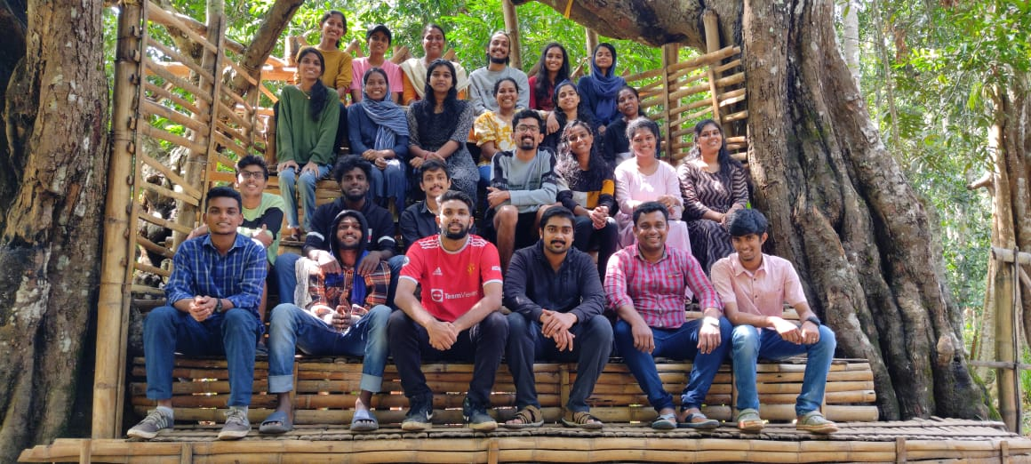
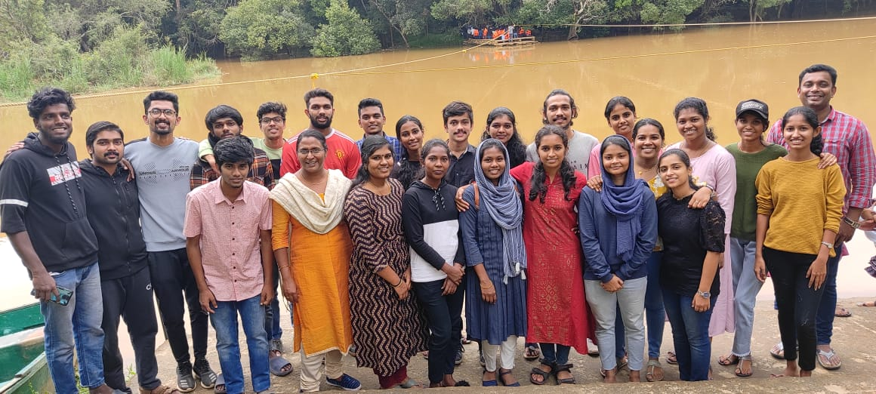
P.G. DEPARTMENT OF COMMERCE
REPORT OF WEBINAR ON ‘Ways of Effective Wealth Creation’
P G Department of Commerce in association with SEBI-IAP and Axis Mutual Fund-Investor Awareness Program organized a one-day webinar on the topic, ‘Ways Of Effective Wealth Creation’ on 27th September 2021 from 3.30 to 5pm. The webinar was inaugurated by the Principal and the technical session was handled by the speaker Mr. K Thangaraj who is a domain expert in Capital Market. He led the session on Mutual Fund and Financial Planning to the students of department. Around 64 students and 5 faculties has participated.
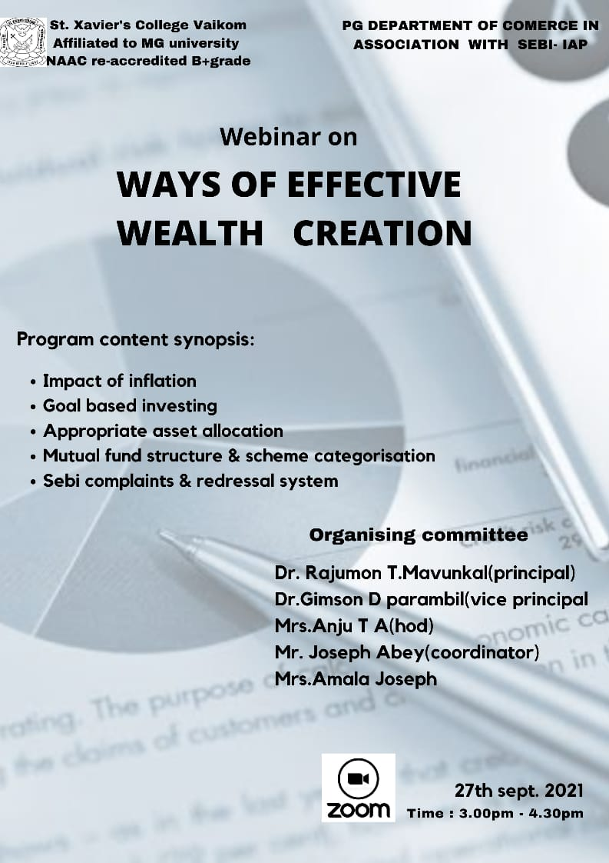

P.G. DEPARTMENT OF COMMERCE
REPORT OF WEBINAR ON ‘Welcome to The World of Business’
To assist our students to acquire the knowledge, information, skills and experience to identify career options and narrow them down to make one career decision, P.G Department of Commerce have organized a webinar on ‘Welcome to the World of Business’ in association with IQAC St. Xavier’s College Vaikom and Logic School of Management on 23rd October 2021. The session was inaugurated by the Principal Dr. Rajumon T Mavunkal and the resource person for the webinar was Mr. Midhun Mitwa, Career Consultant. 73 students and 3 faculties has participated. The webinar helped the students to reflect on their ambitions, interests, qualifications and abilities to be a responsible global citizen.
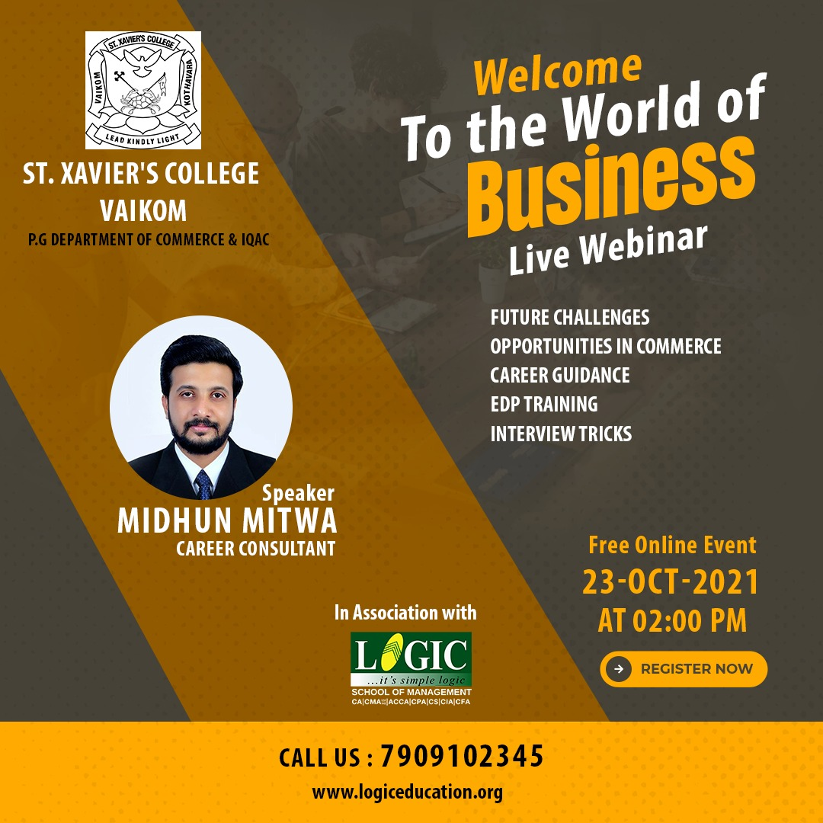
P.G. DEPARTMENT OF COMMERCE
REPORT OF WEBINAR ON ‘Career as A Company Secretary’
P G Department of Commerce in association with ICSI Kochi Chapter organized a Career Awareness Programme on the topic ‘Career as a Company Secretary’. The session was handled by C S Mithun B Shenoy Company Secretary, Kitex Garments Ltd on 28th October 2021. He has shared the opportunities of a CS professional and his experience. He has also shared the course structure, registration formalities and internship. Around 45 students have participated.
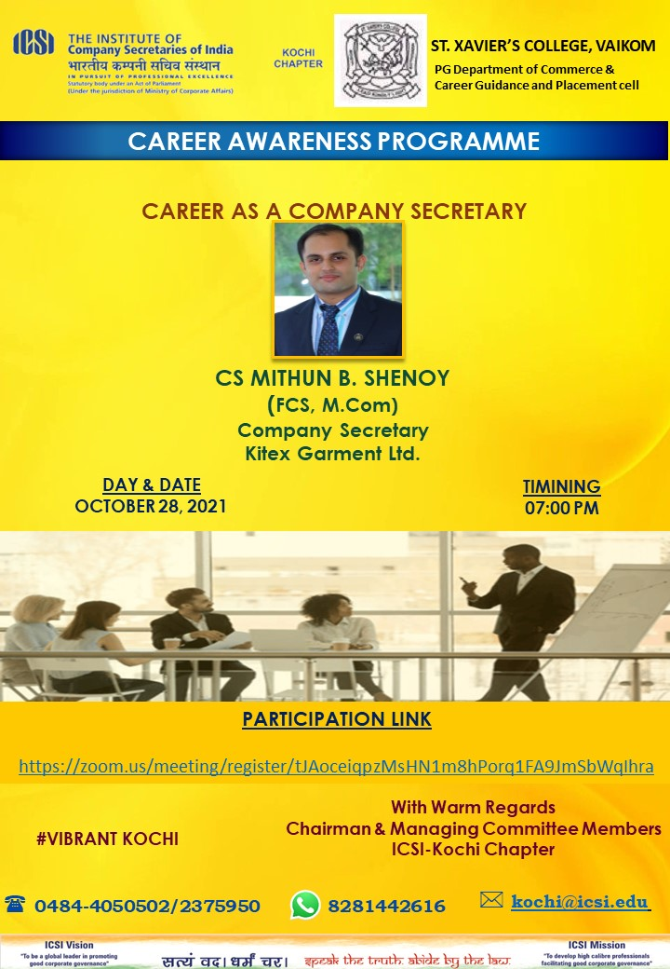

P.G. DEPARTMENT OF COMMERCE
REPORT OF WEBINAR ON ‘Overview of Securities Market & Career Growth’
It has been empirically proven that finance provides viable and lucrative career opportunities. The pandemic has triggered supernormal growth in new investors in equity, mutual funds, insurance and other financial products. To make an awareness among the youngsters Commerce Department has organized a webinar on ‘Overview of Securities Market & Career Growth’ in association with IQAC St. Xavier’s College Vaikom and BSE Ltd on 30th October 2021. The session was inaugurated by the Vice Principal Dr. Gimson D Parambil and the resource person for the webinar was Mr. Manoj T. Neelakantan Ex-AGM IDBI Bank, BFSI Trainer, RP-IICA SMART SEBI and 84 students participated. The webinar has made the participants well awareness regarding emerging trends in securities market.
